Lauren Apuzzo

Neden

English 9

Image Share

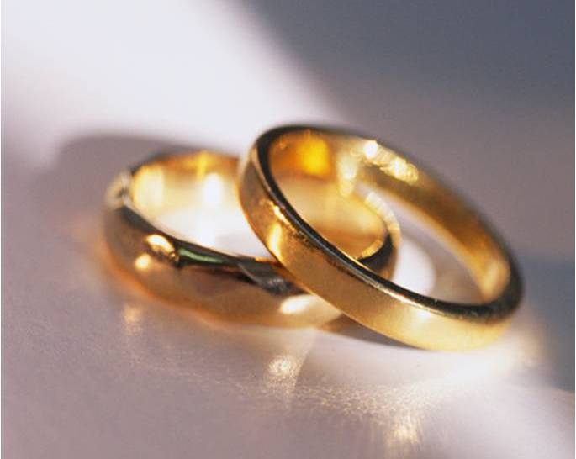

Act 2, Scene 3

In this scene, Romeo goes to the church to meet Friar Laurence who is a priest. Friar is in the garden collecting herbs when Romeo comes to him asking if he can marry them. The priest is upset with Romeo because he feels that every beautiful girl that he sees, he marries. “Young men’s love then lies Not truly in their hearts, in in their eyes.” By this he means that just a few days ago he was madly in love with Rosaline and now he is ready to be married to a different girl. Although Friar recognizes that Romeo is simply infatuated with Juliet but not in love with her, he agrees to marry them. He does this because he thinks it will mend the problems between the families which will make Verona a happier place.

I do not think that the wedding will solve any problems but instead make the problems between the families worse and the families will probably blame each other. I think that Romeo doesn’t really love Juliet although he cares about her. I think that he just wants to rebel against his parents because throughout time children will always want to go against their parent’s word.